Monitoring:
- Monitoring is a continuous process of observing:
  - Health
  - Performance
  - Usage
- With monitoring, you can collect data:
  - CPU usage
  - Memory usage
  - Disk space usage
  - Uptime
  - Error logs
  - Network traffic
    - Etc…
- With monitoring we monitor:
  - Detect any problems
  - Performance of system(s)
  - Alerts
  - Performing RCA (Root Cause Analysis)
  - Tracking the usage
- Advantages of monitoring:
  - Early alert
  - Performance optimization
  - Reduced downtime
  - Improved security
  - Audit and compliance
- Disadvantages of monitoring:
  - Complex to setup
  - Cost of tools
  - Privacy risk
- Use case:
  - On a windows/linux machine, server runs out of disk.
  - A web application becomes slow.
  - A cloud service going down.
  - CPU usage suddenly spikes.
  - High memory utilization.

Working of a monitoring tool:
- Data collection
  - The monitoring tool collects data from different sources (devices, systems) using different methods.
    - Agent-based method – an agent/a software is required to collect the data.
    - Agentless method – these uses SSH, WMI or APIs to gather the information.
    - Cloud APIs – for AWS, Azure, GCP.
- Data transmission
  - Then the collected data is sent to the monitoring server at regular intervals (few sec, few mins, few hours).
  - It uses various protocols to send the information like, HTTP, HTTPS, TCP/UDP.
- Data processing
  - The monitoring tools then processes/analyses the incoming data.
    - Check for CPU threshold.
    - Applies rules (in case, if threshold exceeds).
    - Stores the data in the monitoring tools’ database.
- Alerts and notifications
  - If any issues are detected then tool will trigger alert(s) using
    - Email
    - SMS
    - Teams message
    - Slack
    - Webhooks
    - Calls
- Visualization and reporting
  - Monitoring tools will show the real-time data
    - Graphs
    - Charts
    - Heatmaps
    - Logs
    - Custom dashboards (Grafana, Kibana)
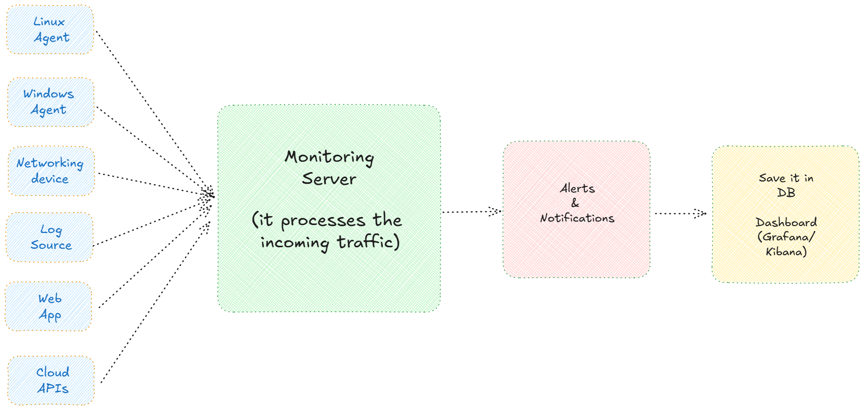

List of monitoring tools:
Monitoring tools can be categorized in 3 categories:
- Free/Open-source tools
- Enterprise/Paid tools
- Cloud monitoring tools
Free/Open-source tools:
- Nagios Core – CLI configuration, highly customizable
- Zabbix – open-source enterprise-level monitoring tool with dashboard
- Prometheus – a free tool integrated with Grafana.
- LibreNMS – networking-focused monitoring tool, good for networking devices.
- Sensu core – for monitoring events within pipeline in Devops.
Enterprise/Paid tools
- Nagios XI – production version with dashboard, GUI (web) and support.
- Zabbix Enterprise support - enterprise-level monitoring tool with dashboard
- SolarWinds Network Performance Monitoring (NPM) – used for network monitoring and alerts.
- Datadog – full-stack cloud monitoring tool, has its own dashboards.
- Dynatrace – AI-driven tool
- New Relic – enterprise-level monitoring tool with cloud support.
- Splunk – real-time metric log and tracing tool. Good for large-environments.
Cloud-based Monitoring tools:
- Amazon CloudWatch – monitor instances, services, logs and so on.
- Azure Monitor – monitoring solution for azure resources
- Google Cloud Operations – Native monitoring tool for google resources.
- Grafana cloud – hosted with Prometheus and Loki.
- ELK – ElasticSearch, logstash and kibana.
- Sentry – for frontend and backend code.

Nagios
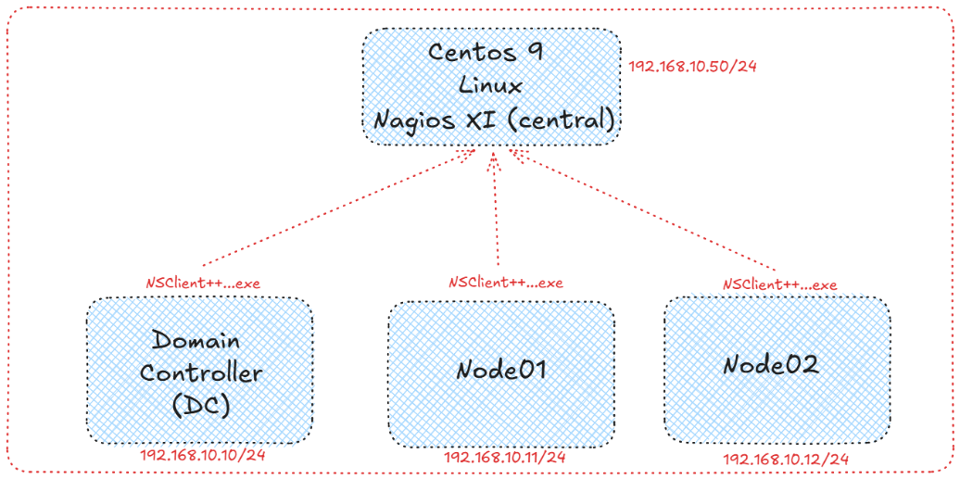
- Nagios is a powerful open-source monitoring tool.
- It helps in monitoring:
  - Systems
  - Network
  - Applications
  - Services
  - Disk drives
  - Processes
  - Hardware temperature.
  - State of the system (offline/online)
    - Etc…
- Nagios comes in 2 modes
  - Nagios Core
    - Free application.
    - Installation requires linux knowledge CLI
    - It is highly customizable.
  - Nagios XI
    - Free only for 60days.
    - Installation, configuration and management of Nagios is done using Web browser.
    - It is GUI.
    - It is an enterprise level monitoring solution.
    - In the paid version, you get support from Nagios organization.
- Nagios architecture:
  - Nagios core
    - Central engine to execute the commands and to process the incoming data.
  - Plugins
    - Scripts/Binaries to work with the Nagios.
    - Ex:
      - Check_ping
      - Check_disk
  - NRPE (Nagios Remote Plugin Executor)
    - This is used for monitoring remote linux/UNIX systems.
  - NSCP (NS Client ++)
    - This is used for monitoring remote windows machines.
  - Web interface
    - GUI to visualize the report, logs, services, notification.
  - Event handlers
    - Scripts that are triggered when alert occurs.
  - Notification system
    - Sends alerts via email, SMS, call, push notifications.

Steps:
- Ping to Google.com from linux (here we will install Nagios XI).
- Ping both Linux and windows machines (add additional NIC, if required).
- Download the required packages for Nagios.
go to /tmp directory
# cd /tmp

run below command to install Nagios
# wget https://assets.nagios.com/downloads/nagiosxi/5/xi-5.11.3.tar.gz

extract the whole Nagios directory.
# tar xzf xi-5.11.3.tar.gz

go inside the directory
# cd nagiosxi

run below command to install the Full Nagios.
#./fullinstall

After successful installation, Login to “http://<linux-server-ip-addres>/nagiosxi” and fill the details.
Restart the “httpd” service using command
- systemctl enable httpd
- systemctl start httpd if this fails.
- systemctl restart httpd even if this fails, then run below commands
# mkdir -p /usr/local/nagiosxi/var/certs

# openssl req -x509 -nodes -days 365 -newkey rsa:2048 \
-keyout /usr/local/nagiosxi/var/certs/nagiosxi.key \
-out /usr/local/nagiosxi/var/certs/nagiosxi.crt

# chmod 600 /usr/local/nagiosxi/var/certs/nagiosxi.key
# chmod 644 /usr/local/nagiosxi/var/certs/nagiosxi.crt

# systemctl restart httpd

Again try,
- systemctl enable httpd
- systemctl start httpd
then login to same URL: http://<linux-server-ip-addres>/nagiosxi

